 | 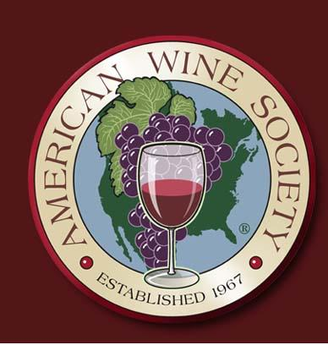 |  | WINE EVALUATION CHART
 |  | Name: |  |  | Date:
 | King George Chapter | Place: |  |  | Topic:
 |  |  | See Reverse Side for Scoring Guidelines
 | Wine | Price | Appearance  3 Max. | Aroma/ Bouquet  6 Max. | Taste/ Texture  6 Max. |  | Aftertaste  3 Max. | Overall  2 Max. |  |  | Total Score  20 Max.
1
2
3
4
5
6
APPEARANCE
3 = Excellent - Brilliant with outstanding characteristic color.
2 = Good - Clear with characteristic color.
1 = Poor - Slight haze and/or slight off color.
0 = Objectionable - Cloudy and/or off color.

AROMA AND BOUQUET
6 = Extraordinary - Unmistakable characteristic aroma of grape variety or wine type. Outstanding and complex bouquet. Exceptional balance of aroma and bouquet.
5 = Excellent - Characteristic aroma. Complex bouquet. Well balanced.
4 = Good - Characteristic aroma. Distinguishable bouquet.
3 = Acceptable - Slight aroma and bouquet. Pleasant.
2 = Deficient - No perceptible aroma or bouquet or with slight off odors.
1 = Poor - Off odors.
0 = Objectionable - Objectionable or offensive odors.

TASTE AND TEXTURE
6 = Extraordinary - Unmistakable characteristic flavor of grape variety or wine type. Extraordinary balance. Smooth, full-bodied and overwhelming.
5 = Excellent - All of the above but a little less. Excellent but not overwhelming.
4 = Good - Characteristic grape variety or wine type flavor. Good balance. Smooth. May have minor imperfections.
3 = Acceptable - Undistinguished wine but pleasant. May have minor off flavors. May be slightly out of balance, and/or somewhat thin or rough.
2 = Deficient - Undistinguished wine with more pronounced faults than above.
1 = Poor - Disagreeable flavors, poorly balanced, and/or unpleasant texture.
0 = Objectionable - Objectionable or offensive flavors and/or texture.

AFTERTASTE
3 = Excellent - Lingering outstanding aftertaste.
2 = Good - Pleasant aftertaste.
1 = Poor - Little or no distinguishable aftertaste.
0 = Objectionable - Unpleasant aftertaste.

OVERALL IMPRESSION
2 = Excellent
1 = Good
0 = Poor

TOTAL SCORES
18 - 20 = Extraordinary
15 - 17 = Excellent
12 - 14 = Good
9 - 11 = Commercially Acceptable
6 - 8 = Deficient
0 - 5 = Poor and Objectionable

The American Wine Society is a national non-profit consumer organization which is dedicated to educating its members and the general public about wine appreciation, production and use. The society is an independent organization with no commercial affiliation.

The society has chapters throughout the United States and Canada. Membership is open to anyone interested in wine — amateur, enthusiast, or professional.

For further information contact:

AMERICAN WINE SOCIETY
3006 LATTA ROAD
ROCHESTER, NY 14612

716-225-7613
Local contact:

King George Chapter

President: Brad Hanna

